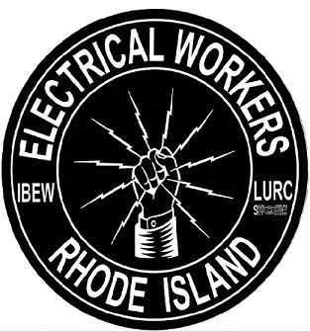
2nd Annual Toy Drive

Local 2323RidingClub
Benefiting HASBRO Children’s Hospital

Please donate new unwrapped toys, games or books for all ages.
Please keep in mind infants (0-2) and teens (13-17).

Deadline for donations will be December 18, 2017
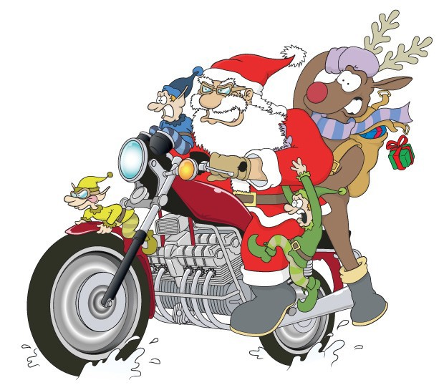
Collection Boxes will be available downtown and at all garage locations or you can see..

Rich Cabaceiras - FSC Ron Dickinson - Tower Hill
JoAnn LaRose – EP
Ray Cimino-Smithfield Mike Enos - Warwick

